
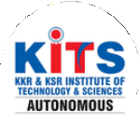
KKR & KSR Institute of Technology and Sciences
(Autonomous)
Approved by AICTE, New Delhi and Permanently Affiliated to JNTUK, Kakinada
Accredited by NBA-Tier-I(WA) & NAAC with Grade ‘A’.

KITS ACM STUDENT CHAPTER

INAUGURATION FUNCTION

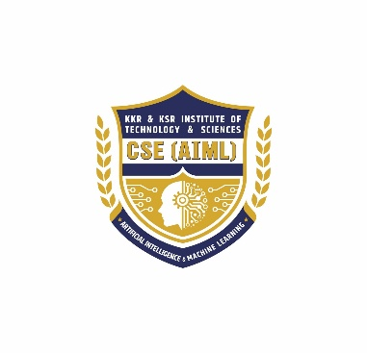
Date : 07.10.2025 Venue: Sir C.V.Raman Hall

Organized by
DEPARTMENT OF CSE (AI & ML)

INAUGURATION FUNCTION
Number of ACM Students attended: 15

Number of Professional Members attended: 3
Number of students attended : 316
Welcome Address:
The Department of Computer Science and Engineering (Artificial Intelligence and Machine Learning) at KKR & KSR Institute of Technology and Sciences (Autonomous) organized the Grand Inauguration of the KITS ACM Student Chapter on [insert date] with great enthusiasm and pride. The event marked a significant milestone in promoting research, innovation, and technical excellence among students.
The program commenced at 10:00 AM with an introduction about ACM, the world’s largest educational and scientific computing society, which inspires professionals and students to advance computing as a science and profession.
Agenda and Proceedings:
1. Introduction about ACM (10:00 AM – 10:05 AM):
The event began with an overview of the Association for Computing Machinery (ACM), highlighting its mission to provide resources that advance computing education and research globally.
2. Welcoming the Dignitaries and Chief Guest (10:05 AM – 10:15 AM):
The dignitaries, including the Chairman Sir, Secretary Sir, Principal Sir, Head of the Department, Faculty Coordinators, and Chief Guest, were warmly welcomed by the hosts. A cordial and respectful ambiance was established to honour their presence.
3. Jyothi Prajwalana (10:15 AM – 10:18 AM):
The ceremonial lighting of the lamp (Jyothi Prajwalana) was performed, symbolizing the dispelling of ignorance and the spreading of knowledge. All the dignitaries took part in this traditional ritual.
4. Prayer Song (10:18 AM – 10:22 AM):
A melodious prayer song followed, creating a serene and positive atmosphere for the inauguration ceremony.
5. Induction of Office Bearers (10:22 AM – 10:50 AM):
The office bearers of the newly formed ACM Student Chapter were introduced. Their roles and responsibilities were explained, emphasizing their contribution to the smooth functioning and success of the chapter’s activities.

6. Opening Remarks by Faculty Coordinator (10:50 AM – 11:10 AM):
Dr. S. Radhakrishnan Sir, Faculty Coordinator, delivered the opening remarks. He highlighted the objectives of the ACM chapter, its benefits for students, and the importance of active participation in research and innovation.
7. Felicitation Address by Head of the Department (11:10 AM – 11:30 AM):
The Head of the Department appreciated the efforts of the faculty and students in establishing the chapter. He encouraged students to utilize the platform for professional growth and technical excellence.
8. Felicitation Address by Principal Sir (11:30 AM – 11:50 AM):
The Principal Sir addressed the gathering and emphasized the role of ACM in shaping the careers of budding engineers. He motivated the students to participate in global-level technical events and conferences through ACM.
9. Felicitation Address by Secretary Sir (11:50 AM – 11:57 AM):
The Secretary Sir expressed his happiness about the formation of the chapter and extended his support for its upcoming initiatives and events.
10. Felicitation Address by Chairman Sir (11:58 AM – 12:05 PM):
The Chairman Sir congratulated the department and the students for their initiative. He also shared his insights about the importance of global exposure in the field of Artificial Intelligence and Computing.
Chief Guest Session:
11. Introduction of Chief Guest (12:05 PM – 12:10 PM):
The Chief Guest of the event was introduced with a brief note on his achievements and contributions in the field of technology and education.
12. Inaugural Address by the Chief Guest (12:10 PM – 12:35 PM):
The Chief Guest delivered an inspiring inaugural address. He emphasized the importance of research, innovation, and ethical practices in computing. He motivated students to make use of ACM resources to enhance their technical knowledge and professional network.
13. Releasing of Calendar of Events and Launching of Website (12:35 PM – 12:45 PM):
The official calendar of ACM activities and the chapter’s website were launched by the Chief Guest and dignitaries. The website aims to keep students updated about upcoming events, workshops, and achievements.

14. Felicitation to the Chief Guest (12:45 PM – 12:50 PM):
A memento was presented to the Chief Guest as a token of gratitude for his valuable presence and inspiring address.
Closing Ceremony:
15. National Anthem (12:50 PM – 1:00 PM):
The event concluded with the National Anthem, invoking a sense of pride and unity among all attendees.
Conclusion:
The inauguration of the KITS ACM Student Chapter was a grand success, setting a strong foundation for future academic and research endeavour. The session not only motivated students but also created awareness about the importance of being a part of global professional communities like ACM.
The Department of CSE (AI & ML) extends heartfelt gratitude to all dignitaries, faculty members, and students who contributed to making this event a memorable one. The chapter aims to organize workshops, hackathons, coding contests, and seminars in the upcoming months to nurture innovation and excellence in computing.

KITS ACM STUDENT CHAPTER INAUGURATION CERMONY

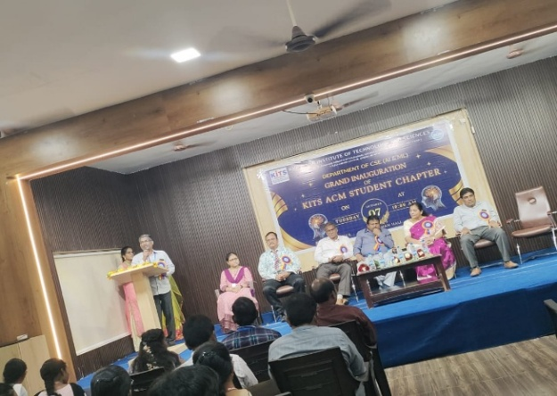  “Felicitation by Dr.G.Murali Garu” | 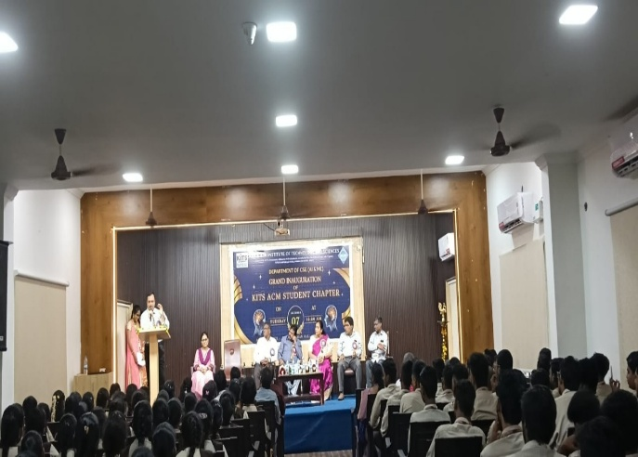  “Opening remarks by Dr.S.Radhakrishnan Sir”
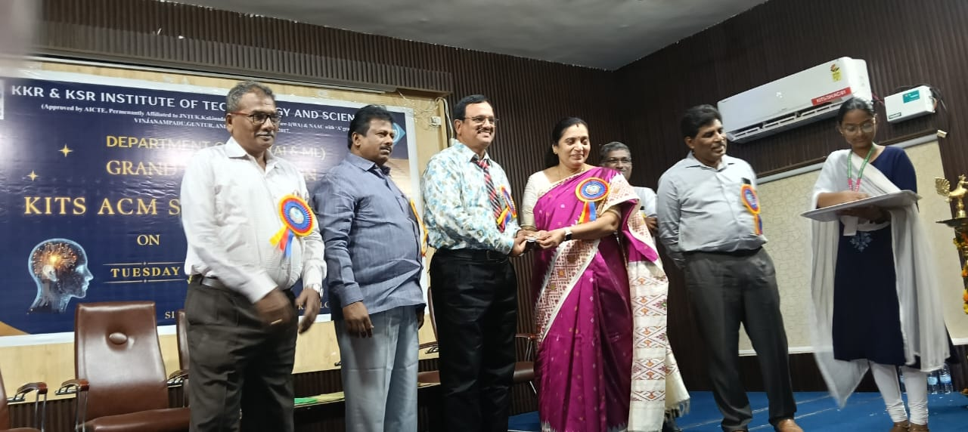  “Presenting Membership cards ” | 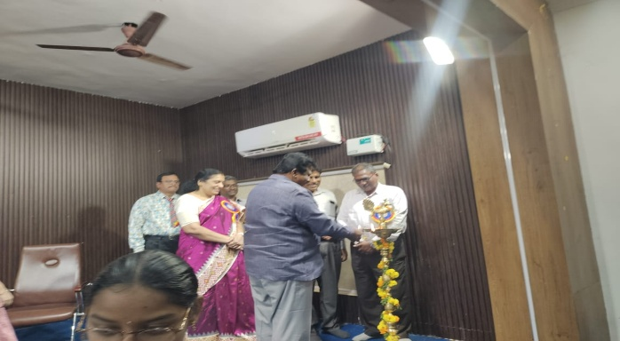  “Jyothi Prajwalana Cermony”
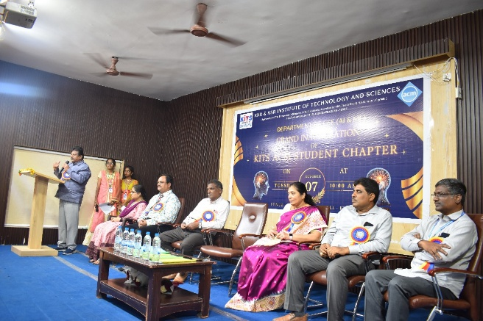 | 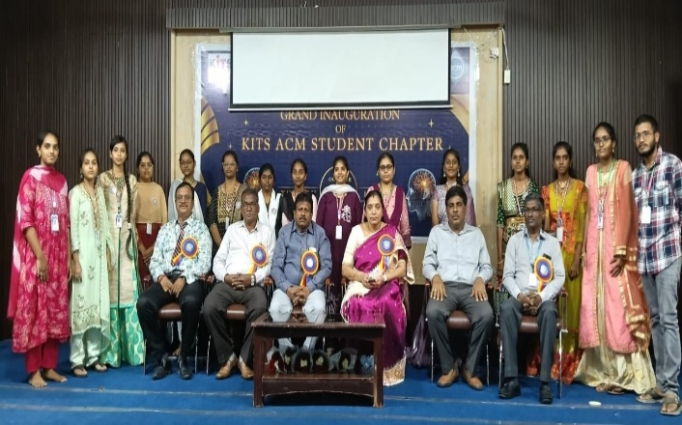  “KITS ACM Student Chapter”
“Chairman Dr.Koye.Subbarao Garu addressing the students”
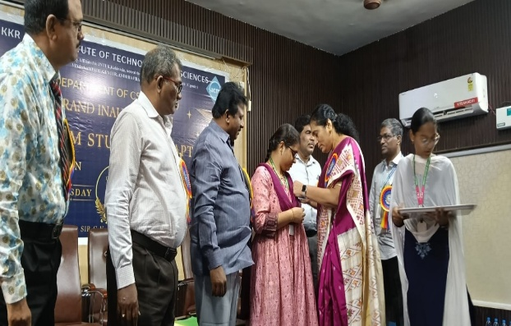 | 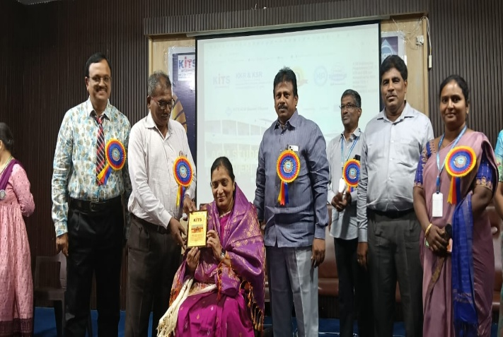
“Induction office Bearers” | “Felicitation for Chief Guest Dr.M.Sreelatha Garu”
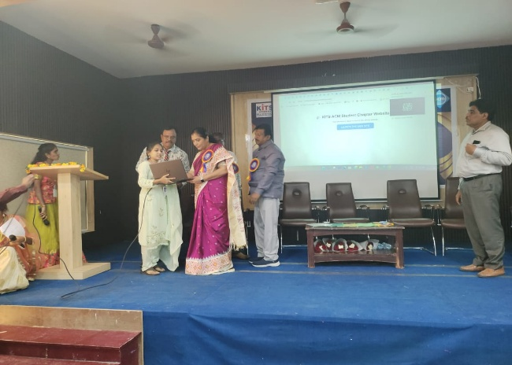 | 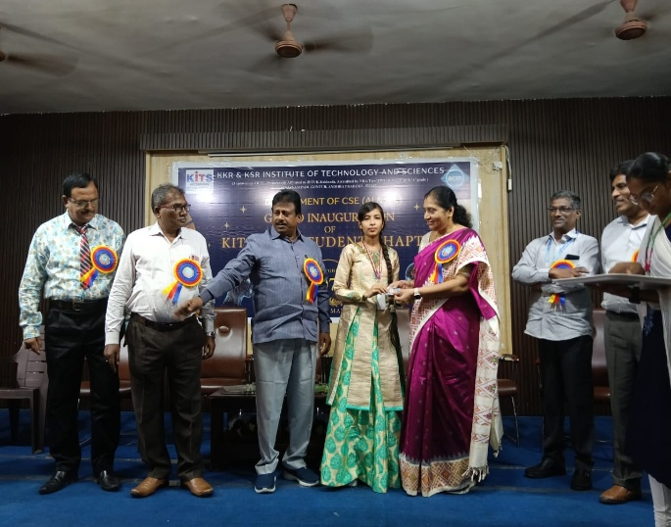
“Launch of Kits ACM Student Chapter Website” | “ACM Membership Cards for office all inducted students”
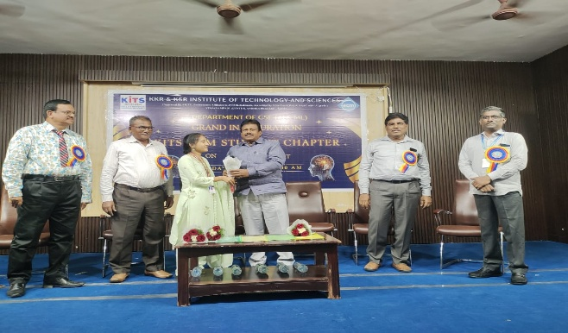 | 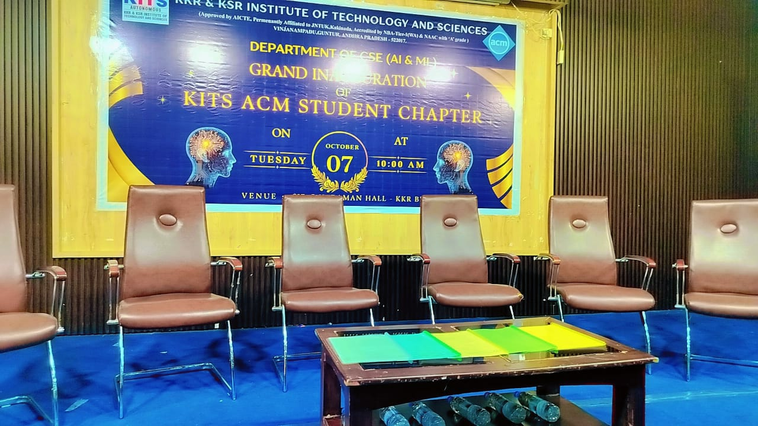
“welcoming chairman sir on to the stage” | “Inaugural stage for KITS ACM Student chapter”

